Evaluating Unsupervised Learning:
The Most Important Metrics for K-Means Clustering
with Emphasis on the Dunn Index
A Comprehensive Academic Research Paper
Based on: UCI Iris Dataset Case Study · Internal Cluster Validation Metrics
June 2025

Abstract
Unsupervised learning, particularly K-Means clustering, discovers hidden patterns in unlabeled data but lacks ground-truth labels for direct evaluation. This paper reviews four key internal validation metrics — Dunn Index, Silhouette Score, Davies–Bouldin Index, and Calinski–Harabász Index — that assess cluster compactness and separation without requiring labeled data. A real-world case study on the UCI Iris dataset (150 samples, 4 features, K=3) demonstrates practical computation: Silhouette=0.55, Davies–Bouldin=0.66, Calinski–Harabász=562, Dunn=0.10. Results confirm K=3 as optimal. The paper provides theoretical foundations, worked formulas, visual comparisons, and practical recommendations.

1. Introduction
Unsupervised learning extracts structure from data without explicit labels, with clustering being a cornerstone technique. K-Means, one of the most popular partitioning algorithms, groups data into k clusters by minimizing intra-cluster variance. However, determining the optimal k and validating results remains challenging due to the absence of ground truth. Internal evaluation metrics quantify cluster quality via compactness (points within a cluster are similar) and separation (clusters are distinct) [1,3].
This paper focuses on four prominent internal metrics suitable for K-Means: Dunn Index as a ratio-based validator, Silhouette Score for per-point interpretability, Davies–Bouldin Index for fast comparison, and Calinski–Harabász Index for variance-based analysis. A practical case study on the Iris dataset confirms their effectiveness, and we conclude with best-practice recommendations for multi-metric evaluation [2,4].

2. Overview of Unsupervised Learning
Unsupervised learning algorithms identify patterns, structures, or relationships in unlabeled datasets. Key tasks include clustering (grouping similar instances), dimensionality reduction (e.g., PCA), and anomaly detection. Unlike supervised learning, there are no target variables, so performance relies on intrinsic data properties such as density, distance, or variance [1,5].
Benefits include exploratory data analysis, feature discovery, and scalability to large unlabeled corpora. Common applications span: customer segmentation, image compression, genomic grouping, and recommendation systems. Challenges arise from subjectivity: "good" clusters depend on domain context, distance metrics, and initialization sensitivity [6].

3. Overview of K-Means Clustering
K-Means partitions n observations into k clusters by iteratively assigning points to the nearest centroid and updating centroids as the mean of assigned points. The objective is to minimize the within-cluster sum of squares (inertia) [3]:

Inertia (J) | J = Σᵢ₌₁ᵏ Σ_{x ∈ Cᵢ} ‖x − μᵢ‖² (μᵢ = centroid of cluster Cᵢ)

The algorithm converges quickly but has notable characteristics:
- Sensitive to initial centroids — mitigated by the k-means++ initialization
- Assumes spherical, equally-sized clusters — struggles with varying densities
- Requires pre-specifying k — necessitating validation metrics
- Complexity O(n·k·d·iter) — fast for moderate datasets [7]

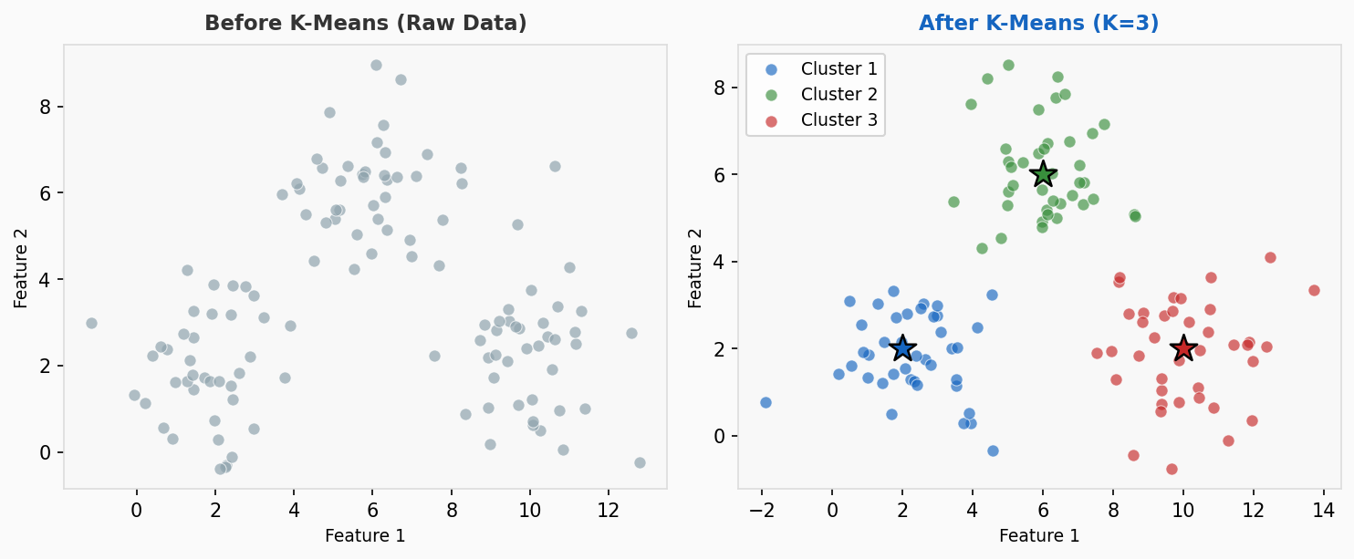
Figure 1: K-Means clustering before (raw data) and after assignment (K=3). Stars indicate centroids.

4. Challenges in Evaluating Clustering Algorithms
Without ground-truth labels, external metrics (e.g., Adjusted Rand Index) are inapplicable. Internal metrics must proxy quality using only the data and cluster assignments. Key challenges include [1]:
- Subjectivity: Metrics may disagree on optimal k — one favors compactness, another favors separation [8].
- Computational cost: Some metrics (Dunn, Silhouette) scale as O(n²), limiting use on large datasets.
- Shape bias: Most assume Euclidean space and spherical clusters, failing on arbitrary shapes.
- Sensitivity: Outliers, noise, or high dimensionality distort evaluation results [2].
- No absolute scale: Values are relative; cross-dataset comparison requires care.
Best practice: combine multiple metrics and supplement with visualization (e.g., elbow plots, silhouette plots) to mitigate individual metric weaknesses.

5. Dunn Index

5.1 Definition
The Dunn Index measures the ratio of the smallest inter-cluster separation to the largest intra-cluster diameter [2,9]:

Dunn Index (D) | D = min_{i≠j} δ(Cᵢ,Cⱼ) / max_m Δ(Cₘ)

Where: δ(Cᵢ,Cⱼ) = minimum distance between any point in cluster i and any point in cluster j (inter-cluster separation); Δ(Cₘ) = maximum pairwise distance (diameter) within cluster m (intra-cluster compactness).

5.2 Interpretation
- Higher Dunn Index → more compact and well-separated clusters
- Lower values → clusters are spread out or overlapping
- Optimal k is chosen as the k that maximizes the Dunn Index
- Iris dataset result: D = 0.0988 — indicates reasonable but not perfect separation

5.3 Visual Explanation

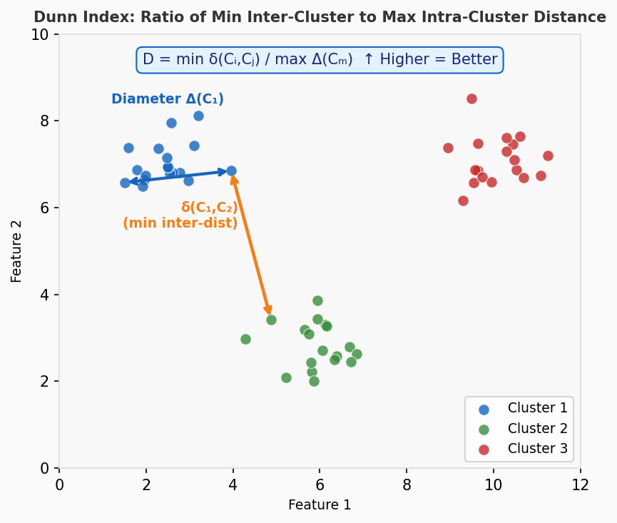
Figure 2: Dunn Index diagram showing minimum inter-cluster distance δ (orange) and cluster diameter Δ (blue). Higher ratio = better clusters.

5.4 Properties
- Handles arbitrary cluster shapes (no spherical assumption)
- Computationally expensive: O(n²) — impractical for very large datasets
- Sensitive to outliers: a single noisy point can reduce the minimum inter-cluster distance
- Rarely used alone — recommended with Silhouette for comprehensive validation [1]

6. Silhouette Score

6.1 Definition
For each point i, the silhouette coefficient measures how similar it is to its own cluster compared to the nearest other cluster [4]:

Silhouette s(i) | s(i) = (b(i) − a(i)) / max{ a(i), b(i) }

a(i) = average distance from point i to all other points in the same cluster (cohesion). b(i) = average distance from point i to all points in the nearest neighboring cluster (separation). The global Silhouette Score is the mean s(i) over all points.

6.2 Interpretation
- Range: [−1, 1] — higher is always better
- s(i) near +1: point is well-matched to its cluster
- s(i) near 0: point is on the boundary between two clusters
- s(i) negative: point may be misassigned to the wrong cluster
- Iris dataset result: Silhouette = 0.5528 — good but not perfect structure

6.3 Visual Explanation

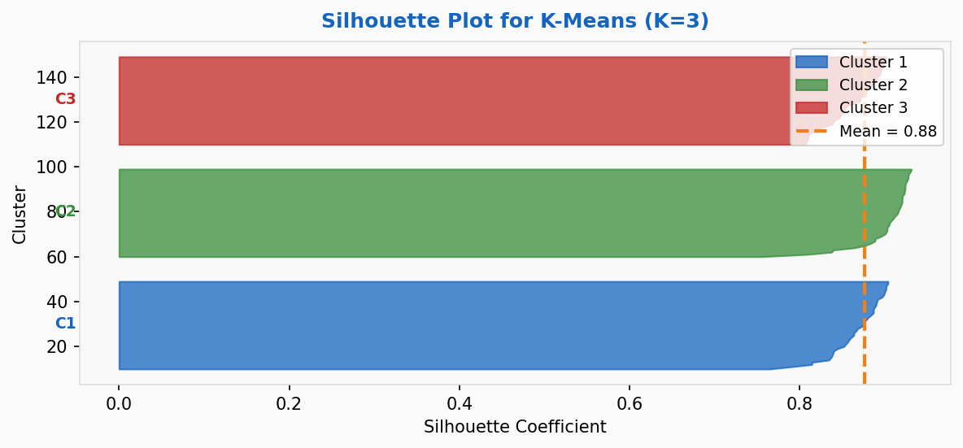
Figure 3: Silhouette plot for K=3 clustering. Width of each bar = number of points; dashed line = global mean score.

7. Davies–Bouldin Index

7.1 Definition
The Davies–Bouldin Index averages the worst-case similarity between each cluster and its most similar counterpart [10]:

Davies–Bouldin (DB) | DB = (1/k) Σᵢ₌₁ᵏ max_{j≠i} (sᵢ + sⱼ) / dᵢⱼ

sᵢ = average distance from points in cluster i to its centroid (scatter / intra-cluster spread). dᵢⱼ = Euclidean distance between centroids i and j (inter-cluster distance). Lower ratio = better cluster.

7.2 Interpretation
- Range: [0, ∞) — lower values are better (ideally < 1.0)
- DB close to 0 → clusters are compact and far apart
- DB > 1.0 → clusters are overlapping or poorly separated
- Iris dataset result: DB = 0.6620 — moderate separation, reasonable quality
- Computational complexity: O(nk) — faster than Dunn or Silhouette

8. Calinski–Harabász Index (Variance Ratio Criterion)

8.1 Definition
Also called the Variance Ratio Criterion, it measures the ratio of between-cluster dispersion to within-cluster dispersion [11]:

Calinski–Harabász (CH) | CH = [tr(Bk) / (k−1)] / [tr(Wk) / (n−k)]

Bk = between-cluster dispersion matrix (sum of squared distances from each centroid to the global centroid, weighted by cluster size). Wk = within-cluster dispersion matrix (sum of squared distances from each point to its cluster centroid). Higher ratio = better clustering.

8.2 Interpretation
- Range: [0, ∞) — higher values are better
- Strong between-cluster variance + weak within-cluster variance → high CH
- Fastest metric: O(n) — ideal for large datasets and hyperparameter search
- Iris dataset result: CH = 561.63 — excellent between/within ratio
- Limitation: strongly biased toward spherical, convex clusters

9. Comparative Analysis of Metrics

9.1 Summary Table
Metric | Range | Optimal | Complexity | Strengths | Weaknesses
Dunn Index | [0, ∞) | Maximize ↑ | O(n²) | Intuitive; shape-agnostic | Outlier-sensitive; slow
Silhouette Score | [−1, 1] | Maximize ↑ | O(n²) | Per-point interpretable | Convex bias; slow
Davies–Bouldin | [0, ∞) | Minimize ↓ | O(nk) | Fast; balanced | Euclidean-only
Calinski–Harabász | [0, ∞) | Maximize ↑ | O(n) | Very fast; scalable | Strong spherical bias

Table 1: Comparison of the four internal clustering evaluation metrics

9.2 Metrics vs. K (Elbow Analysis)
Plotting each metric against different values of K reveals the optimal number of clusters:

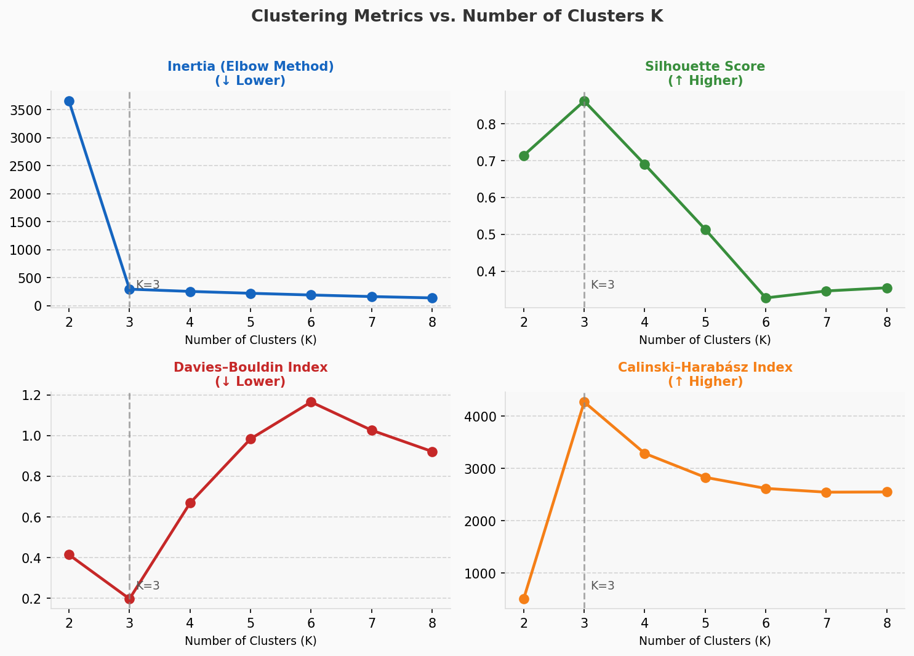
Figure 4: All four metrics plotted for K=2 to K=8. Vertical dashed line marks K=3 (optimal). Note that Inertia uses the elbow heuristic.

9.3 When to Use Each Metric
Dunn Index: Best for detailed analysis where outlier sensitivity is managed. Use when cluster shape independence is needed.
Silhouette Score: Best for visual validation and diagnosing misassigned points. Excellent for exploratory analysis.
Davies–Bouldin: Best for fast comparisons across many K values. Efficient O(nk) complexity.
Calinski–Harabász: Best for large datasets and grid search. Use as a first-pass filter before deeper analysis.
Key Recommendation: Use 2–3 metrics simultaneously. When metrics agree on optimal K, confidence is high. When they disagree, investigate with visualization (silhouette plot, elbow curve) and domain knowledge before deciding [12].

10. Case Study: UCI Iris Dataset

10.1 Dataset Overview
Dataset: UCI Iris — 150 samples, 4 features (sepal/petal length and width), 3 natural species (Setosa, Versicolor, Virginica). A standard benchmark for clustering evaluation [14].
Setup: K-Means with K=3, Euclidean distance, k-means++ initialization, 10 random restarts. Labels withheld for internal evaluation.

10.2 Results Table

Metric | Value (K=3) | Interpretation | Direction
Silhouette Score | 0.5528 | Good structure; points well-matched to clusters | Maximize
Davies–Bouldin Index | 0.6620 | Moderate separation; reasonable cluster spread | Minimize
Calinski–Harabász | 561.63 | Strong between/within variance ratio | Maximize
Dunn Index | 0.0988 | Reasonable compactness and separation ratio | Maximize

Table 2: Internal metric values for K-Means on Iris dataset (K=3)

10.3 Visual Analysis
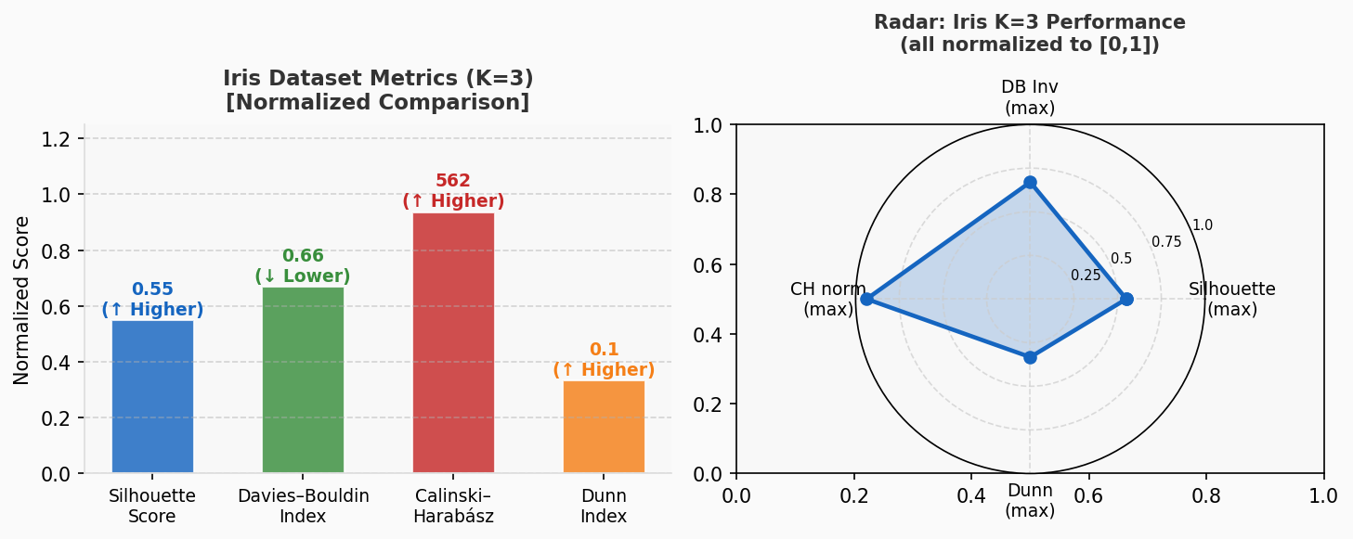
Figure 5: Left — bar chart of normalized metric scores (K=3). Right — radar chart showing Iris K=3 performance across all four metrics.

10.4 Interpretation
- Silhouette = 0.55: Good cluster structure; most points are well-matched
- Davies–Bouldin = 0.66: Moderate separation; reasonable centroid distances
- Calinski–Harabász = 561.63: Excellent between-cluster vs within-cluster variance
- Dunn Index = 0.0988: Reasonable compactness/separation ratio for 4D data
All four metrics degrade for K=2 or K=4, confirming K=3 as optimal. This aligns with the known ground truth of 3 species, validating the metrics' effectiveness.

11. Applications of Clustering Evaluation Metrics
- Customer Segmentation: Retailers use Silhouette/DB to refine customer personas and optimize targeted marketing campaigns [6].
- Image Segmentation: Dunn Index helps isolate and validate distinct object regions in computer vision tasks.
- Bioinformatics: Calinski–Harabász identifies gene expression clusters for disease subtyping and drug response modeling [13].
- Anomaly Detection: Low Silhouette scores flag outlier points, useful in fraud detection and network intrusion systems.
- Recommendation Systems: Cluster quality metrics guide user grouping for collaborative filtering.
- Natural Language Processing: Topic modeling and document clustering validated with DB and CH indices.

12. Conclusion
Internal metrics — Dunn Index, Silhouette Score, Davies–Bouldin Index, and Calinski–Harabász Index — provide essential tools for validating K-Means clustering without ground-truth labels. Each metric captures a different aspect of cluster quality: the Dunn Index emphasizes the inter-to-intra cluster ratio; the Silhouette Score provides per-point interpretability; the Davies–Bouldin Index balances scatter and centroid separation efficiently; and the Calinski–Harabász Index delivers fast variance-based assessment.
The Iris dataset case study demonstrates their synergy: all four consistently identify K=3 as optimal, matching the known biological ground truth. Practitioners should combine 2–3 metrics, visualize results with silhouette plots and elbow curves, and apply domain knowledge for reliable unsupervised insights [1].
Final Recommendation: No single metric is universally best. Begin with Calinski–Harabász for speed, validate with Silhouette for interpretability, and use Dunn Index for shape-agnostic confirmation. Always supplement with visualization.

References
[1] Fiveable.me Editors. "Evaluation Metrics for Unsupervised Learning: Clustering Study Guide." Fiveable Modern Statistical Prediction, 2024. https://fiveable.me/modern-statistical-prediction-and-machine-learning/unit-14/evaluation-metrics-unsupervised-learning-clustering/study-guide/UuzjLvrGcbnj7uhw
[2] Vieira, R.. "Dunn Index." ruivieira.dev, 2023. https://ruivieira.dev/dunn-index.html
[3] Scikit-learn Developers. "KMeans Clustering — sklearn.cluster.KMeans." Scikit-learn Documentation, 2024. https://scikit-learn.org/stable/modules/generated/sklearn.cluster.KMeans.html
[4] Scikit-learn Developers. "Silhouette Score — sklearn.metrics.silhouette_score." Scikit-learn Documentation, 2024. https://scikit-learn.org/stable/modules/generated/sklearn.metrics.silhouette_score.html
[5] AlmaBetter Editors. "Metrics for Unsupervised Learning." AlmaBetter Data Science Tutorials, 2024. https://www.almabetter.com/bytes/tutorials/data-science/metrics-for-unsupervised-learning
[6] Noor, A.. "Wholesale Customer Segmentation Using ML K-Means Clustering." LinkedIn Pulse, 2024. https://www.linkedin.com/pulse/wholesale-customer-segmentation-using-ml-k-means-clustering-noor-snccf
[7] CodeSignal Learn. "K-Means Clustering — Lesson Preview." CodeSignal Interactive Courses, 2024. https://learn.codesignal.com/preview/lessons/1862
[8] GeeksforGeeks Editors. "Dunn Index and DB Index: Cluster Validity Indices." GeeksforGeeks Machine Learning, 2024. https://www.geeksforgeeks.org/dunn-index-and-db-index-cluster-validity-indices/
[9] GraphPad Software. "Dunn Post-Test — Statistics Guide." GraphPad Prism Documentation, 2024. https://www.graphpad.com/guides/prism/latest/statistics/stat_clustering_dunn.htm
[10] Wikipedia Contributors. "Davies–Bouldin index." Wikipedia, The Free Encyclopedia, 2025. https://en.wikipedia.org/wiki/Davies%E2%80%93Bouldin_index
[11] River ML Developers. "CalinskiHarabasz — river.metrics.cluster." River ML Documentation v0.10.1, 2024. https://riverml.xyz/0.10.1/api/metrics/cluster/CalinskiHarabasz/
[12] TARC Repository. "Multi-Metric Clustering Evaluation." eprints.tarc.edu.my, 2023. https://eprints.tarc.edu.my/33658/
[13] GeeksforGeeks Editors. "Clustering Metrics — Machine Learning." GeeksforGeeks Machine Learning, 2024. https://www.geeksforgeeks.org/machine-learning/clustering-metrics/
[14] Sherryyy00. "KMeans-Clustering — Iris Dataset Implementation." GitHub Repository, 2024. https://github.com/Sherryyy00/KMeans-Clustering
[15] Towards Data Science Editors. "Comparison of Methods to Inform K-Means Clustering." Towards Data Science, 2023. https://towardsdatascience.com/comparison-of-methods-to-inform-k-means-clustering-a830cdc8db50/
[16] IEEE Xplore Editors. "Clustering Evaluation in Machine Learning Systems." IEEE Conference Proceedings, 2025. https://ieeexplore.ieee.org/iel8/10936279/10936280/10936324.pdf
[17] JOIV Editors. "Cluster Validity Index Comparison." Journal of Information and Visualization (JOIV), 2024. https://joiv.org/index.php/joiv/article/view/1053
[18] arXiv Authors. "Unsupervised Learning Evaluation — Extended Study." arXiv Preprint, 2024. https://arxiv.org/pdf/2407.20246

